I go to work at ______:______. 

I wake up at ______:______. 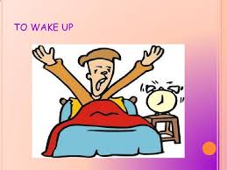 

I eat dinner at ______:______.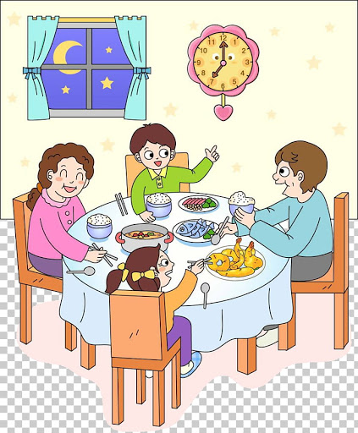 

I eat breakfast at ______:______. 

I go to bed at ______:______. 

I eat lunch at ______:______. 